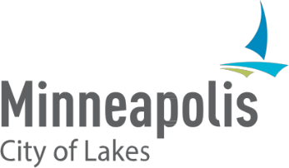 | Licenses and Consumer Services  505 Fourth Ave S., Room 220  Minneapolis, MN, 55415  612-673-2080  www.minneapolismn.gov
Notice of Public Hearing

DBA: Somali Community Resettlement Services (SCRS)

Purpose: To gather public opinion and solicit comments regarding the application from Somali Community Resettlement Services (SCRS) for a Rental Hall and an Extended Hours License. If approved, they intend to provide private and public events for their community center
Place: Minneapolis City Hall, Room 317, 350 South 5th Street, Minneapolis, MN 55415
Date: September 26, 2023
Time: 1:30 p.m. or shortly after that
Applicant's Name (Legal Entity): Somali Community Resettlement Services (SCRS)
Complete Address: 2115 Stevens Ave Minneapolis, MN 55404
Telephone Number: 612-540-9737
Current License(s): None
Requested License(s): Rental Hall and an Extended Hours License
Zoning District: BFI3/RM3, Zoning approved as a community center
Neighborhood and Ward: Whittier and 10
Proposed Hours of Operation: Interior: Sunday to Thursday, 8:00 a.m. - 12:00 p.m.; Friday and Saturday, 8:00 a.m. to 2:00 a.m.
This application is subject to final approval of all ordinance requirements, which may include zoning, health, criminal background, and financial reviews. You are invited to express your opinions and/or submit such in writing by contacting Inspector Mohamed Ismail at 612-673-3904, Mohamed.Ismail@minneapolismn.gov, or 505 Fourth Ave S, Room 220, Minneapolis, MN 55415.
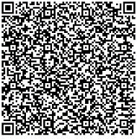
Request accessible format: If you need help with this information, please email 311, or call 311 or 612-673-3000. Please tell us what format you need. It will help us if you say what assistive technology you use. People who are deaf or hard of hearing can use a relay service to call 311 or 612-673-3000.
Information in Other Languages: Para asistencia 612-673-2700. Rau kev pab 612-673-2800. Hadii aad Caawimaad u baahantahay 612-673-3500.
This notice was posted on September 6, 2023.

